
Dixon Street Flats, Central Wellington - Update 2025
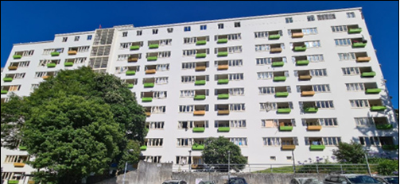
The Dixon Street Flats at 134 Dixon Street in central Wellington have been used as social housing for more than 80 years. However, the age, condition, and configuration of the 117 units within the 11-storey building mean they no longer fit the needs of our customers and not suitable for continued social housing use.
We have supported all the customers who were living in the Dixon Street Flats to move into other Kāinga Ora homes that that are warmer, healthier, and better suited to their needs.
What’s happening now with the building?
We are boarding up the building while we decide what to do with it long-term. We have sought advice from Heritage New Zealand Pouhere Taonga and obtained resource consents from Wellington City Council so that we can secure the building and ensure its safety while it is vacant. The security measures that we are putting in place will help protect both the building and the surrounding area.
The building’s age, condition, and configuration mean it needs a substantial amount of upgrading if we want to keep using it for social housing. For example, many of the building services need replacing, as well as the roof.
The size of the building and the extent of the work means this is likely to be very costly. We need to weigh up whether it is worth spending that money or whether we would better to invest that money on social housing elsewhere in Wellington, for example in our proposed Arlington development.
We could potentially redevelop the site with housing that is more suited to the needs of our customers today, but because the Dixon Street flats are heritage listed, it is unlikely we would get permission to demolish the building. Selling the building might also be an option.
We expect to make a decision on what we will do with the Dixon Street Flats by mid-2025.

The history of the Dixon Street Flats

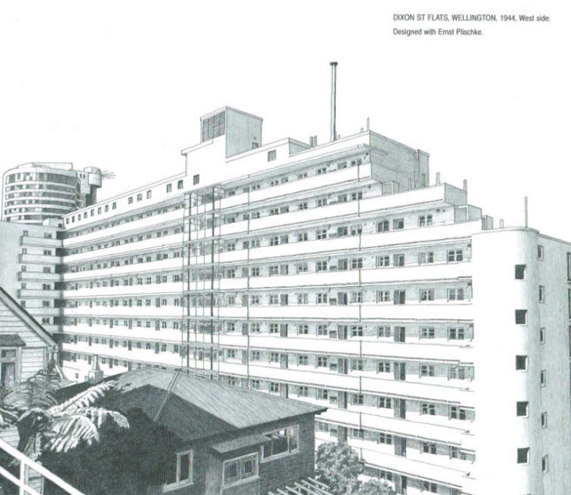

The Dixon Street flats are listed as a Category 1 Historic Place on the New Zealand Heritage List because when they were built in the early 1940s, they were only the second major social housing development in the country.
They are also considered one of the first examples of Modernist architecture in New Zealand.
The flats were designed by the housing construction department of the Ministry of Works, under the direction of government architect Gordon Wilson.



