New housing coming to 16 & 24 South Street
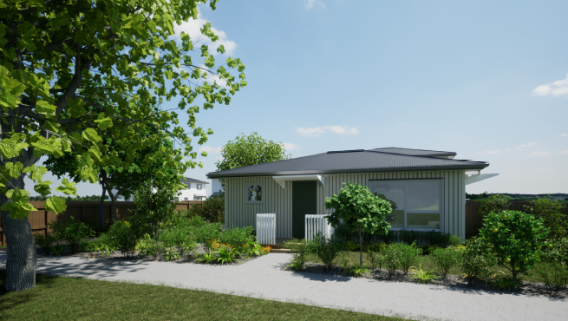
Street view of South Street
We wrote to you previously to let you know we were looking at opportunities for new homes in South Street, Palmerston North.
Kāinga Ora – Homes and Communities have recently received resource consent to build new, warmer, drier homes on our site at 16 & 24 South Street. This will help meet the need for housing in Palmerston North.

What will be built?
In the coming months, we will be starting construction on 9 new homes made up of two, three and four-bedroom homes. These homes will consist of one single storey and 8 double storey homes. The new, low maintenance homes will be fully insulated, with carpets, curtains, and double glazing.

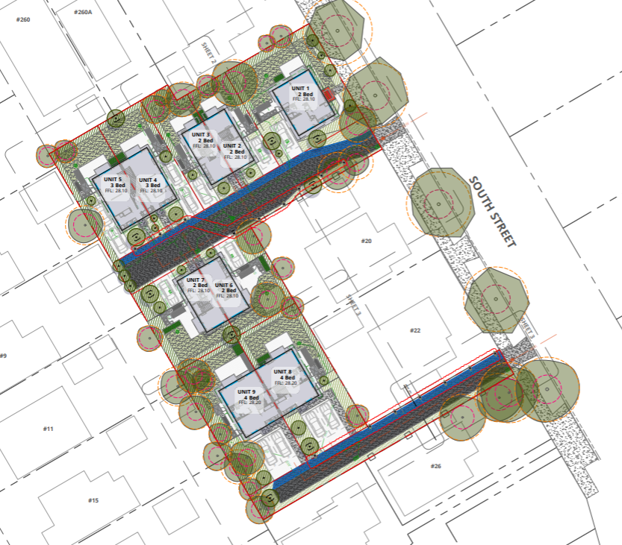
When will building start?
- Start construction............................................. From late 2025
- Finish construction........................................... From mid 2026

Keeping disruption to a minimum
We will ensure that site and traffic management plans are in place for this development. These provide rules and guidelines for what happens during construction.

The plans will cover items like the hours during which work can be carried out, where contractors can park their vehicles and the control of dust and noise. When the construction phase begins, we expect building activity to take place between 7:00am and 6:00pm Monday to Friday and 8:00am to 5:00pm on Saturdays, but not on Sundays and public holidays.

Who will live in the new homes?
Kāinga Ora will match these new homes to individuals and families on the Ministry of Social Developments Housing Register, with the highest priority for a home of that size and in that location.

The size of the homes means they’ll be suitable for families.

Supporting our customers
We always help our new customers settle in to their new home and community. A key focus of ours is to ensure that our customers understand their responsibilities and that includes being good neighbours and connecting with their communities.

Kāinga Ora is also looking at new ways to support our customers and help them connect to support services when and if they need it.

Questions?
To keep up to date with this development or to sign up to receive email updates, please visit engage.kaingaora.govt.nz/palmerston-north.

If you have any further questions, please contact:

Rebecca Kinloch – Community Development Engagement Manager, Kāinga Ora
0800 801 601 (please ask to be transferred)
021 228 3167
rebecca.kinloch@kaingaora.govt.nz

If you are the resident but not the owner of your property, please pass this information on to the owner for their information.

